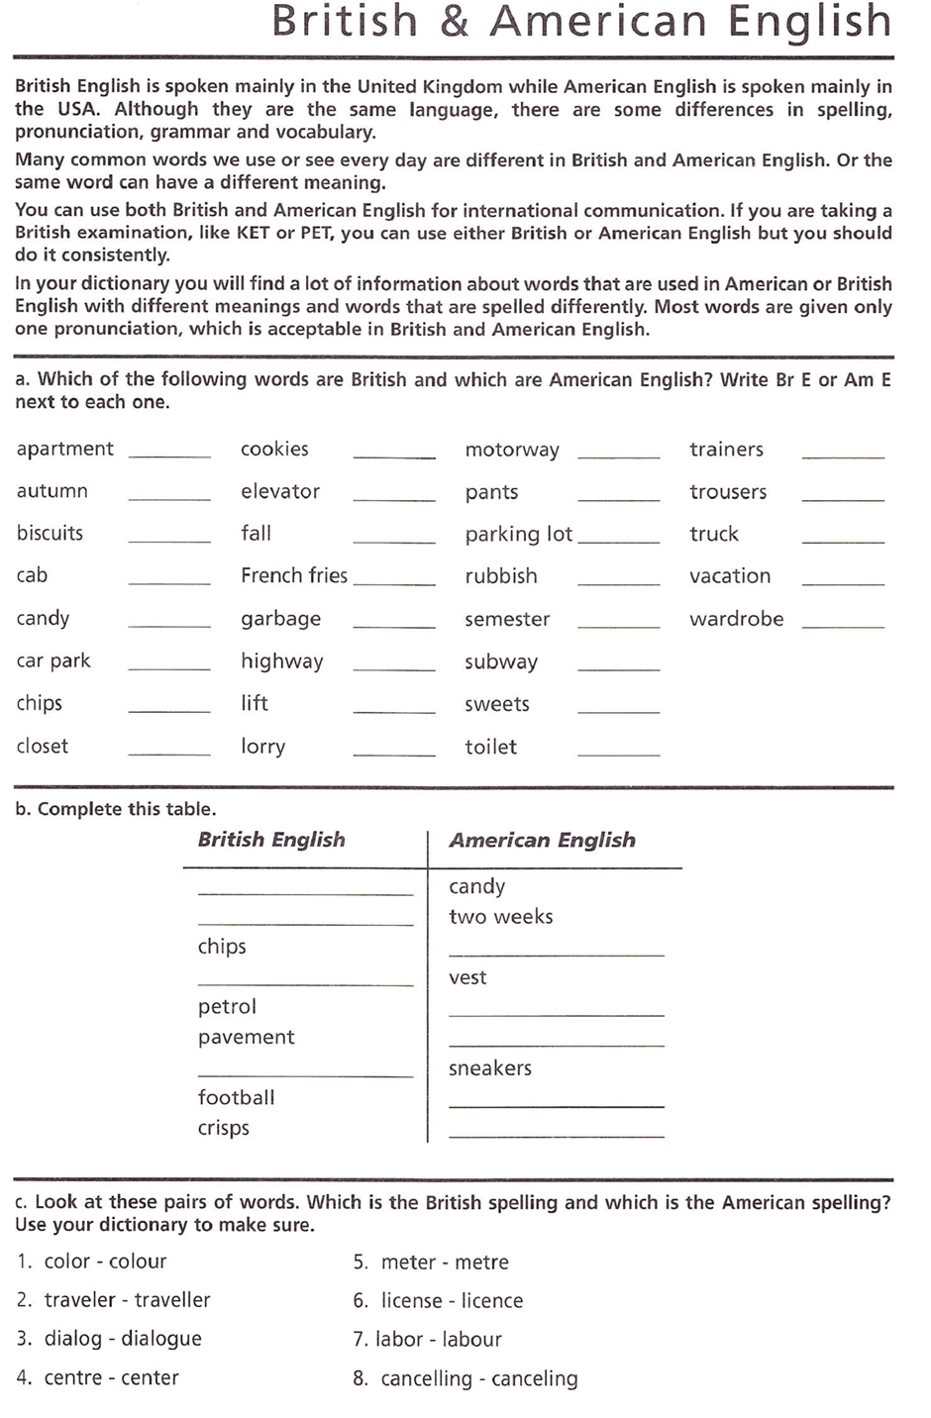

https://learnenglish.britishcouncil.org/how/how-understand-differences-between-british-and-american-english
https://learnenglish.britishcouncil.org/intermediate-grammar/british-english-and-american-english

Language focus: Confusing words

Rob, steal, burgle
Rob- robber (bank, shop, house).
Rob someone/a place
- Robin Hood robbed the rich
- He robbed a bank
- I’ve been robbed

Steal- thief (steals what belongs to s.o. else).
Steal something from someone
- Someone’s stolen my watch
- He stole all my money
- They wanted me to steal your ring
Burgle (break into)- burglar
- My house was burgled last night
- She has been burgled
Mug- asalto, robo a mano armada

High and tall
What is high and what is tall?

Tall: if a thing is higher than it is wide, then we use tall: people, trees, ladders, street lamps, buildings with a lot of floors are tall:
This forest has very tall trees.
I am 1,70 cm tall.
High: we use high for things which are wider:
There are some high mountains in Austria.
Prisons have very high walls.
When talking about measurements, Tall is used for people and High for things. There are things that can be “tall” or “high” depending on the context:
I am 1,70 cm tall
This building is 25 m high/ I live in a very tall building

The adjective High is used when talking about distance above the ground:
The shelf is too high for me to reach. Can you help me?

The clouds are very high today
This park has very tall trees
The woman is six feet tall.
What is the highest mountain in the world?
This building is 75 metres high.
This is a very tall building. It has 30 floors.
The fence was too high for a man of his age to climb

https://learnenglishteens.britishcouncil.org/exams/grammar-and-vocabulary-exams/choose-correct-option

